# TalkBoxConfig High Level

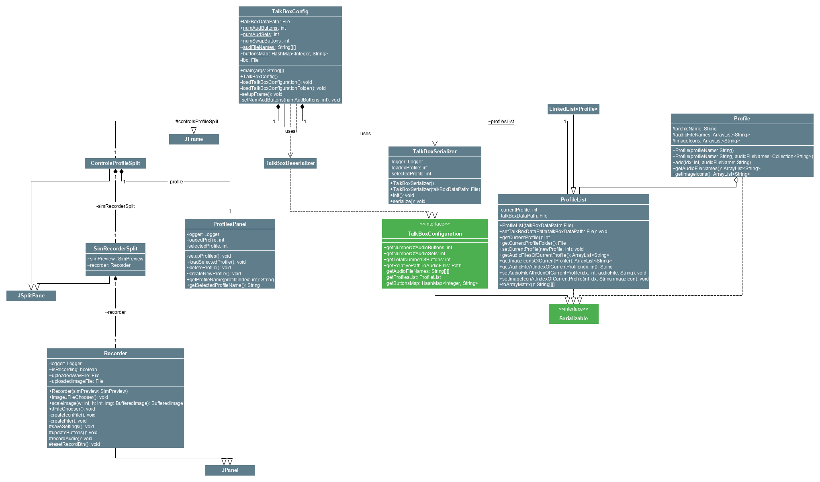

# TalkBoxConfig Low Level

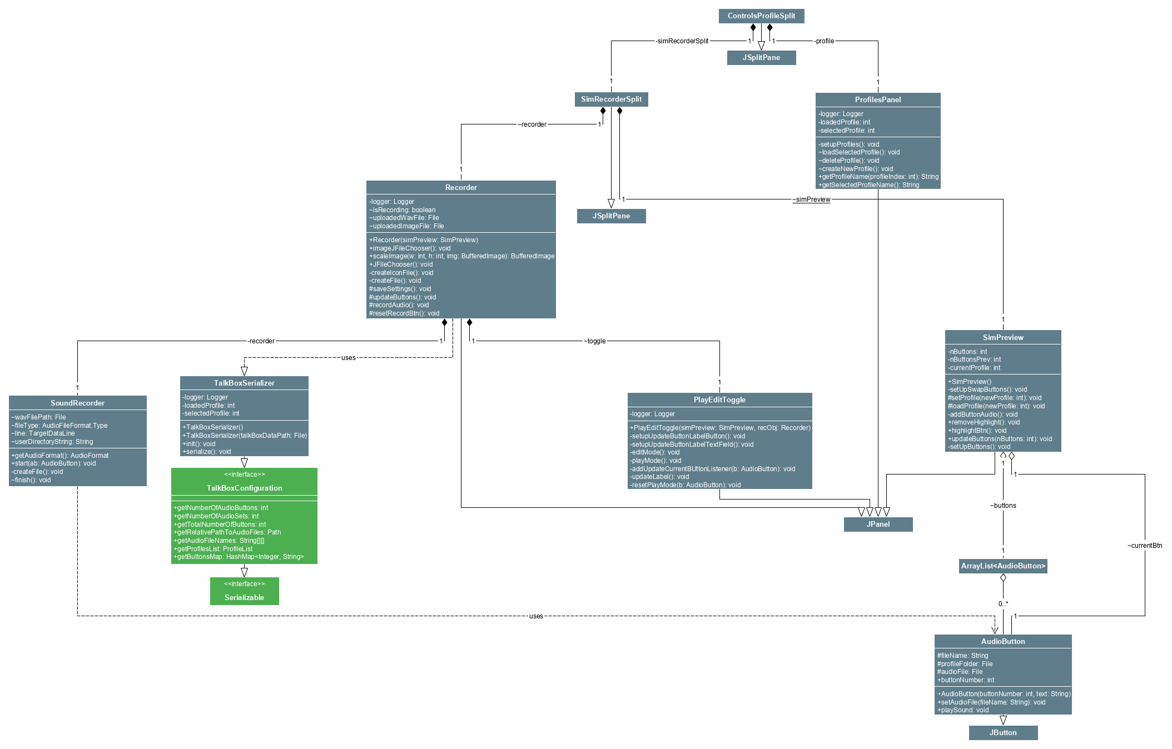

# TalkBoxSim

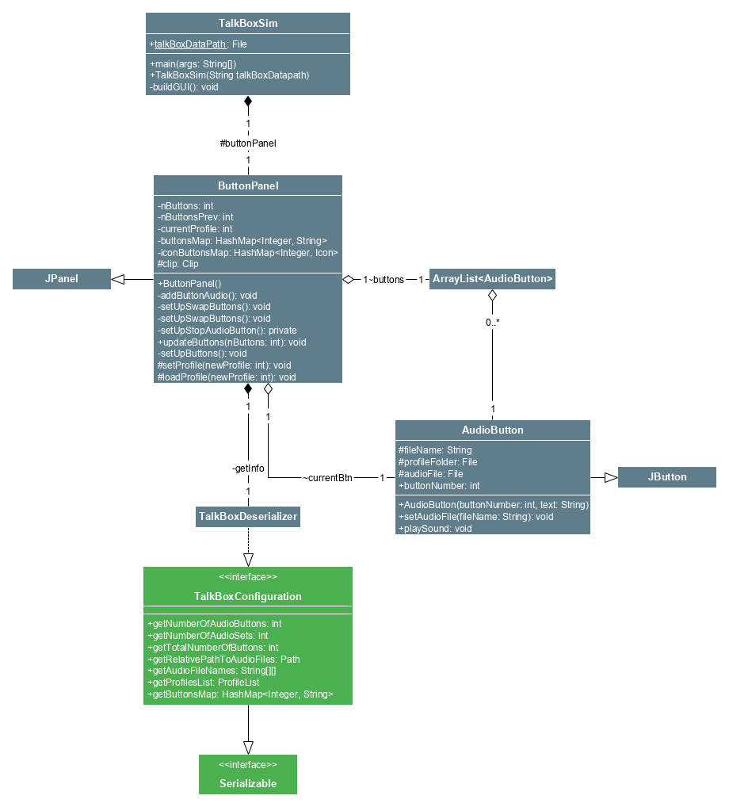

# TBCLog

# 